Dear Traveller I wrote this doc in May 2007, and I later I produced a wiki document that can be updated by everybody.

To have the most updated info, use to it:
Wiki Iraqi Kurdistan document

Backpacking in Iraqi Kurdistan

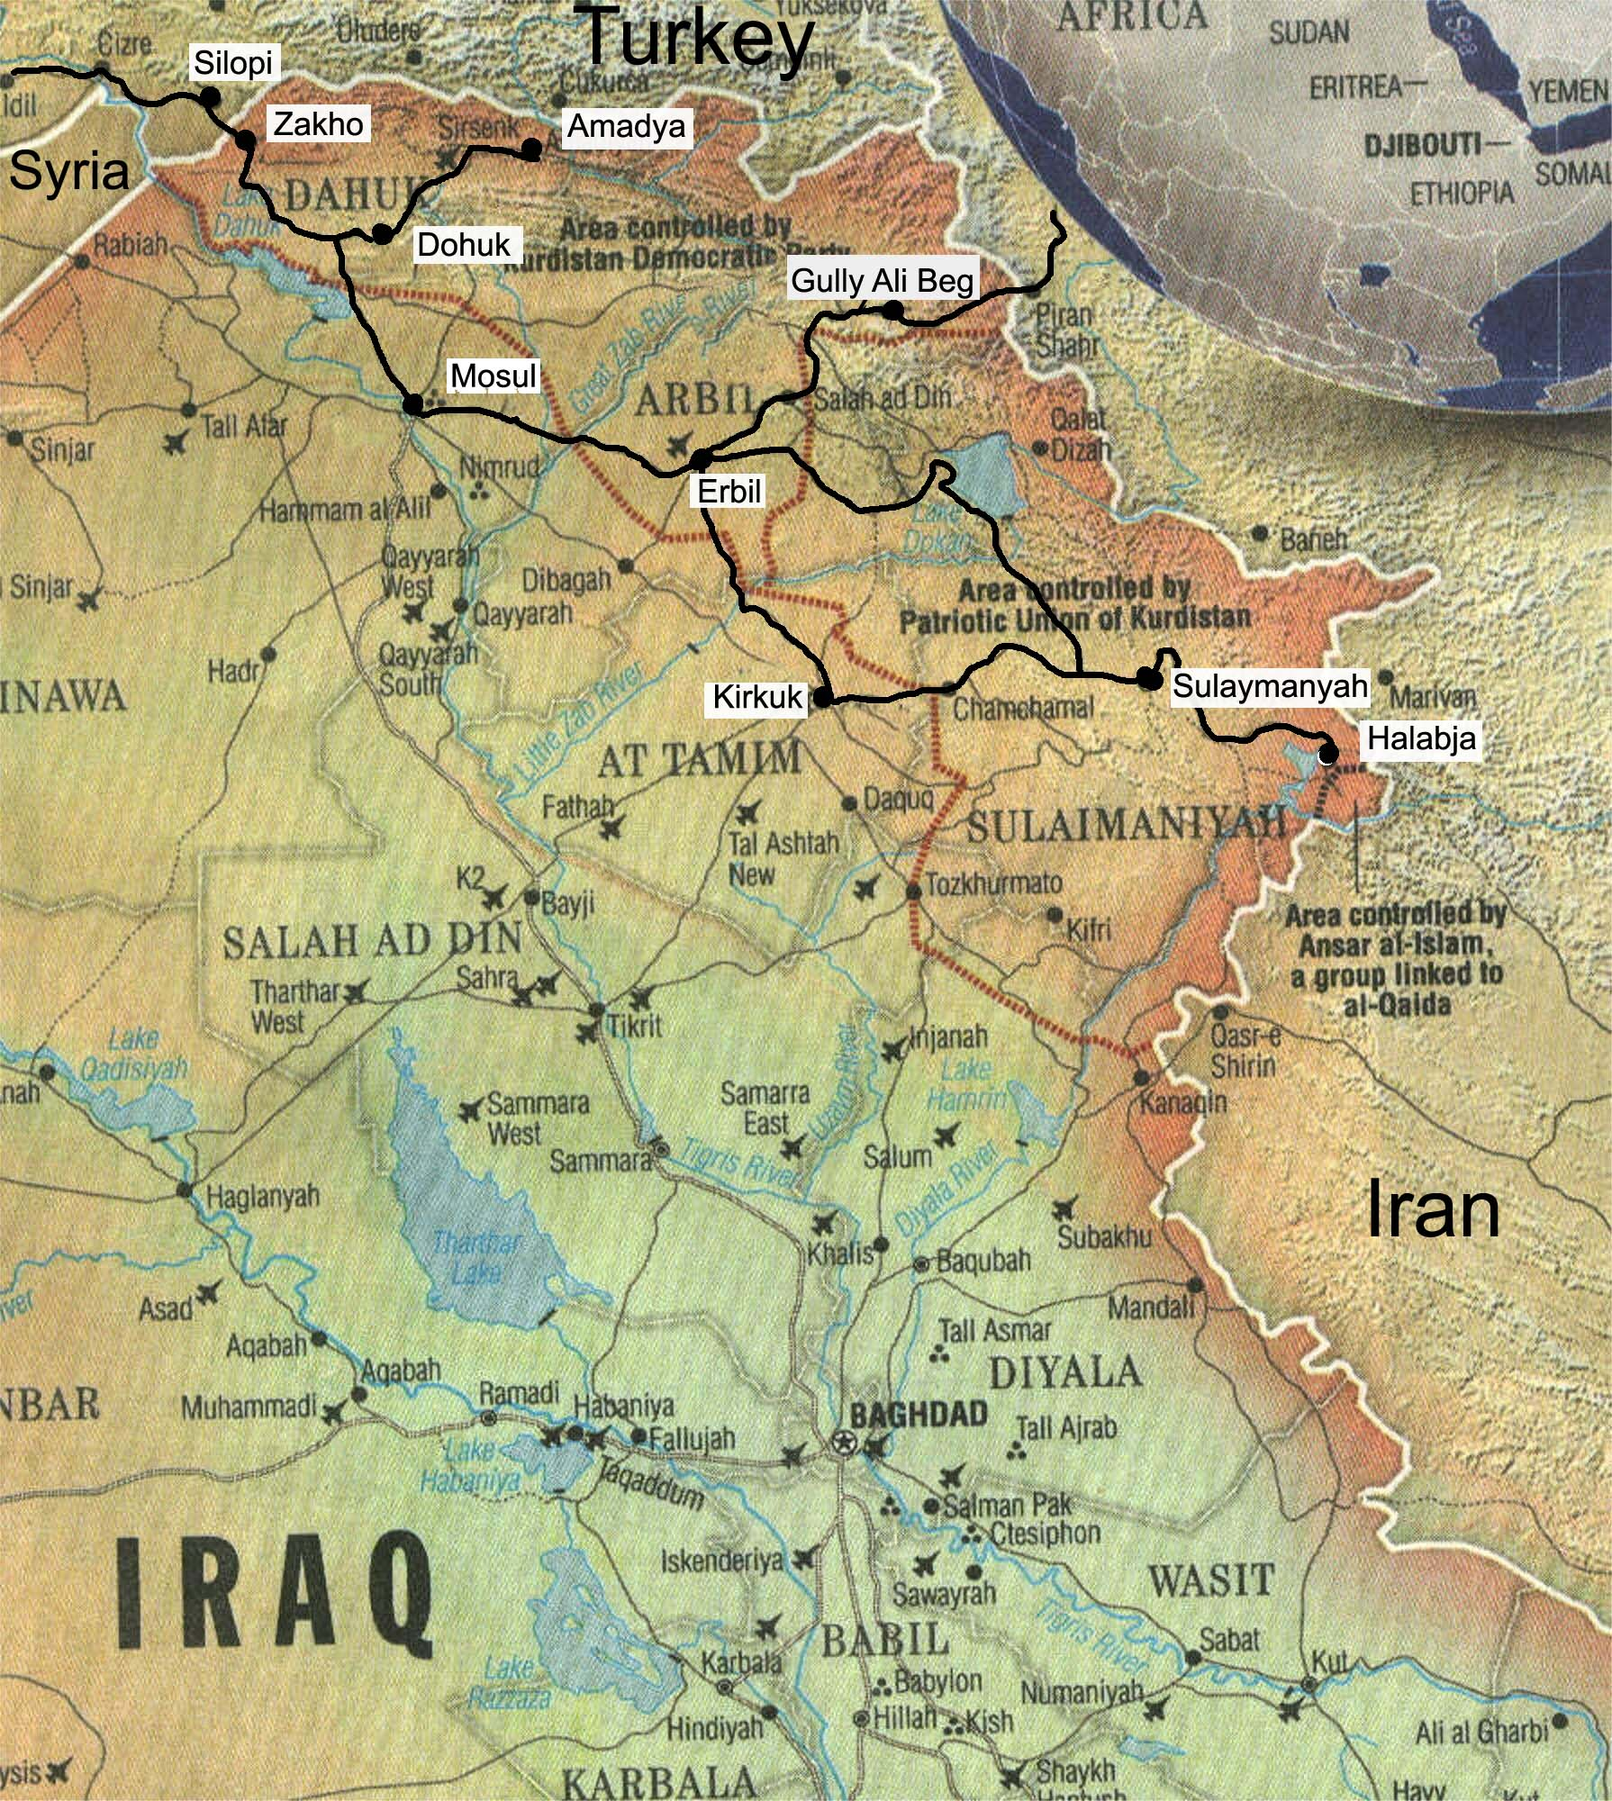

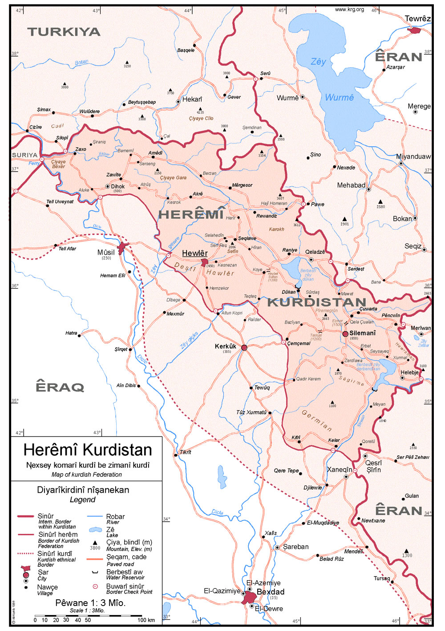

Table of contents

What is this?

Updates

Getting into Iraqi Kurdistan
- To/ from Turkey
- From Diyarbakir to iraqi border
- From Silopi (Turkey) to Zakho (Iraq)
- From Zakho (Iraq) to Silopi (Turkey)
- From Syria
- By Air

Getting around cities
Security
Budget
Money
Climate

Useful links

Dohuk
- What to see
- Hotels
- Getting around
- Getting there

Around Dohuk
- Amedi ('Amadiyah) and Sulaf
- Getting to Amadiya
- Monastery in Al Quash
- Lalish Temple

Erbil
- What to see
- Post office

Hotels
- Getting around

From the airport to the city
- Getting there and away
- Around Erbil
- Rabban (Monk) Beya Monastery

Khanzad Castle
- Gully Ali Beg Resort (Gally Ali Beg)
- Getting to Gully Ali Beg
- Bekhal Resort

Sulaymanyah
- What to see
- Hotels
- Eating
- Drinking
- Post office
- Getting around
- Getting there and away
- Around Sulaymanyah
- Azmar mountain-
- Darbandikhan Dam
- Ahmadawa Resort
- Dokan Lake
- Sarchnar R e s o r t
- Halabja

- Useful Kurdish terms

What is this??

This want be a lively collection of info for those who want to travel in Iraqi Kurdistan. Nowadays there’re so few info about this country that I thought every traveller getting there could give his contribute updating this document, especially as concerns the public means of transports

Instruction:
- Update the documents

Write your name and date in the updates chapter (below)
- Upload it in the net putting a link in the Lonely Planet thorn Tree for Iraq, or if you don’t have any place to upload it in the net, please send to albstrop2006@alice.it, and I’ll do it!

I hope it can work as WIKIPEDIA!

To print this as a booklet
In the printing window (Ctrl+P)> properties> other options…> print using booklet> OK

Updates

Who | Date | Comments and country
http://www.backpackiraq.blogspot.com | Febr 2007 | Did the main thread and the maps
Alby: http://www.albytravel.com | May 2007 | Did the word document. Italy

Getting into Iraqi Kurdistan

To/ from Turkey (Silopi)
The Iraqi- Turkish border is called Habur on the Turkish side and Ibrahim Khalil on the Iraqi side.
It is 9km north of the city of Zakho in Iraq, and 15 km south of the town of Silopi on the Turkish side. Going this way means you don't have to pass through the dangerous parts of Iraq (the non-Kurdish-controlled areas).

From Diyarbakir to iraqi border
Getting by taxi (waste of money)
Taxi for Border Crossing: Line up driver at airport for border crossing. Local drivers will subcontract with an international driver that specializes in border crossings and has the necessary insurance and permits for the trip. You will pay a commission for this brokerage service through a higher fare, so if you want to pay less negotiate directly with an international driver. You can find these drivers at the Crystal Hotel (they sleep and eat for free in exchange for steering their passengers from the Iraq border to such hotels) but they don’t speak much English. I used Firat Gumus, Tel: +90-544-488-36-01 or +90-537-875-51-44. Asking price at Diyarbakir airport will be EUR 180 and the “official” price FROM the Iraq border to Diyarbakir is $ 130, but the drivers are from Silopi & Gizra on the Iraq border and will therefore be desperate to get home and can’t control the fare from Diyarbakir, so you can negotiate a fare as low as $40 since its better than riding empty. (Note: fuel costs in Turkey are high. My driver paid $50 in fuel for the 3 hour trip.) It’s a whole other story from the Iraq border. The drivers all sit under the air-conditioned restaurant at the Ibrahim Al Khalil border where your Iraqi taxi driver will deposit you. They have a monopoly and none will budge for under $130 to Diyarbakir. You can wait for other passengers to share the ride, but be careful, the drivers will ask the Kurds to pay $50 and expect Westerners to pay $80 so demand an equitable split. (Distance: 300kms, takes about 3.5 hours.)]

Getting a bus
Unless you are not extremely short of time, avoid getting a car from Diyarbakir. It’ll be just a waste of money. In fact from Diyarbakir you can easily get to Silopi by bus. Buses go there from Cizre (nearby larger city), Mardin, Diyarbakir, Sirnak, and most likely a few other places.
From Silopi (Turkey) to Zakho (Iraq)
Once in Silopi, the only public transport across the border (15 Km) is by taxi. The local cartel will charge US$40 per taxi for this service (feel free to try to bargain), dropping you off at the taxi rank on the Iraqi side (but should still help you to negotiate your Iraqi taxi fare). The taxi driver should help you at each border check. Before you leave he'll make some photocopies of your passport to give to Turkish passport control.
Crossing the border:
IMPORTANT: Please be aware that the 'Kurdish issue' is very contentious in Turkish politics and it is worth avoiding talking about it with the border officials, or any Turkish security personnel. Also terrorism is a concern for both sides, so don't act suspiciously, or you may end up in trouble.
On the Turkish side it is rather quick for small vehicles to cross- it only took 15 minutes for me. I don't know if my driver bribed anyone or not.
On the Iraqi Kurdistan side, you will sit and wait in a little lounge area, with tea & TV. Kurdish passport control will ask questions about your occupation and reasons for visiting Iraq, and may ask for verification like documents, ID cards, etc. If you have any local contacts they will probably take the name & phone number and give them a call to make sure your story checks out. I have heard that some men travelling alone have been made to wait for a few days at the border- it didn't happen to me but be aware it is possible. Be open and honest, and if you have nothing to hide you should be fine. But it may be easier not to travel alone, and it's definitely preferable to have a local contact to vouch for you.
You don't have to pay for an Iraqi visa if entering by this post, it's just a big fat page-sized stamp in the passport and that's it.
After passport control you might be taken to meet a security official in an office building. He was welcoming to me, and insisted that I contact the local security office if I had any problems anywhere in Kurdistan.
Then you can get a taxi to Zakho (9Km).
In Zakho your driver will drive you another half kilometre to the taxi rank, where you can negotiate a taxi to Dohuk or Erbil, or you can stay in Zakho if you wish. There are bound to be numerous hotels in the centre of this city of perhaps up to 150,000 people. All I saw of Zakho was an industrial border town full of trucks-
From Zakho, a car to Dohuk (around 1 hour) was $45, or $90 to Erbil (3-4 hours). These prices are for one whole car, so if you have 3 passengers divide that by 3. Other travellers will be willing to share a taxi. If you want to get to smaller towns & villages near Zakho, there should be a 'garage' in Zakho where you can find taxis that go to different places, including into the mountains.

From Zakho (Iraq) to Silopi (Turkey)
In Zakho I was asked to pay 16$ for a taxi to Silopi, I refused but they didn’t go any lower.
So I choose to break the travel: from Zakho (to get there from Dohuk, see “getting there and away” in Dohuk) to the turkish border (called Ibrahim Khalil) it’s 9km and a car is 5000 dinar.
Then you pass the Iraqi immigration and it seems you are obliged to take a taxi to pass the turkish part (it seems no possible on foot). The immigration officer told me that the official price from the iraqi border point to Silopi (Turkey, 18 km north of the turkish border point) is 10.000 dinar (the taxi driver asked me 13.000 dinar).
The turkish immigration is a pain in the ass (I was questioned)
If you are from EU at the border you’ll get a Turkish multiple entry visa valid for 3 months for 15$.
To pass the border it took 4 hours!!! I hope you’ll be luckier!

From Syria:
Get to Qamishli, in North-eastern Syria. The 9 hour bus ride from Damascus should cost around SYP300 (US$6). Once in Qamishli, you can walk (10 min) north from the city centre to the border post with Nusaybin, Turkey. If it's too late to cross the border, Hotel Omayya (SYP 300/single, dirty toilets) is a stark little place, in the city centre on the road to the border.
On the Turkish side, in addition to the tourist visa, for which there is usually a fee, there is a small extra 5 lira ($4). Get an overpriced taxi (or walk for 15 min) to the Nusaybin Otogar, from where you can catch a passing bus direct to Silopi (7.5 lira / $6, 2 hours).
By air
There are flights into Erbil and Suleymaniyah from numerous cities, including Baghdad, Amman, Beirut, Dubai, Tehran, Istanbul, Vienna, Stockholm, Copenhagen, Amsterdam, Frankfurt and Munich. The flights are not cheap (except within Iraq). One way international tickets are anywhere from $290 to $500, and return is anywhere from $550 upwards.
Erbil International Airport is currently very small, but a new, larger terminal is due to open around the end of 2007.
Suleymaniyah International Airport was built in 2003, currently with a larger capacity than Erbil.

You can also fly directly to Erbil from Istanbul but this is much more expensive and there is only one flight a week
Istanbul - Erbil –Istanbul ($700 roundtrip or $500 one way)
Tel.: +90 212 465 4410
You can also fly to Erbil from Jordan, Beirut, Dubai, Istanbul or Stockholm, or from Munich or Amsterdam to Suleimani (some flights go via Baghdad). You may need a visa if you go by air since a visa is officially required of everyone entering Iraq. Check with the airlines

To Erbil or Sulaimaniya :Royal Jordanian fly to both cities from Amman. Since RJ are now part of OneWorld (with BA etc), you might be able to ticket all the way through from Edinburgh to Heathrow, Heathrow to Amman, Amman to Erbil/Sulaimaniya. No idea about fares - call their London office 020 7878 6300 to find out

Kurdistan Airlines (which uses Hamburg International planes and crew, wet lease) fly once a week or so from Frankfurt for 660€ rtn to Erbil. You'd just have to get to Frankfurt first....
From dangerous Iraq:
I strongly advise against travelling through Iraq to get to Kurdistan. It is sheer foolishness to go through dangerous parts of Iraq (all areas not controlled by the Kurdish Regional Gov't). Bombs happen, shootings happen, abductions happen, and being foreign will just make you an easier target. Mosul is dangerous, Kirkuk is dangerous, and Baghdad is "much worse than you think" according to people I met.
But if you're already in dangerous Iraq, I presume there are taxis or minibuses from Mosul, Kirkuk and maybe Baghdad to the major Kurdish-controlled cities.
So, I must stress, STAY IN THE KURDISH REGION of Iraq. Don't be a hero and go to Baghdad for the hell of it. It's just total stupidity.

Getting around between cities
The main form of public transport between the major cities in Iraqi Kurdistan is shared taxi. Cars are generally white and orange sedans, some large, some quite small. Some newer, some older and beat-up. The roads between cities are not very safe for driving, with usually just one lane in each direction, and over-taking a dangerous activity. I witnessed one head-on collision.
Generally there is a normal price for one car, and this price is divided by the number of passengers. Usually you will end up waiting until enough passengers come to fill up all the seats.
If for some reason you think travelling in a 4WD/SUV would be safer, think again. They are more likely to be targeted for attacks. I sat next to a VIP in one taxi. He said he travelled like this to stay safe.

Security
Taxis seem to only travel on roads controlled by Kurdish forces. There are LOTS of security checkpoints, probably 10 or more on a 3 hour journey, usually before and after towns. You have nothing to fear at these checkpoints, in fact you should be grateful for them keeping Iraqi Kurdistan safe from terrorists. At some the soldier will just wave the taxi through, but at most ID will be checked. Have your passport ready. At some checkpoints, they'll want to check on foreigners more carefully, and you may end up being questioned by the head official. Just be honest and open and you should be fine. But, if they're suspicious of you, it helps to have a local Kurdish contact who can vouch for you.
Being kind and breaking the ice with some Kurdish sentence like “azmar la Kurdistan” (I like Kurdistan) can help a lot to lower the tension.
Since the main barrier is the language, in particular in the mountains, I found very useful to have a paper written in kurdish saying you are a tourist, where you entered, where you are going to exit the country and how many days your whole trip.
Especially in the small town it can happen that the militaries will come and will take you to the police station. Don’t panic since that just want to verify who you are. In this small places I think the best is to go directly at the police station.
And if you are bloody crazy you can get a taxi or even minibus from Erbil just to Kirkuk, or even Baghdad. Seriously, you would have to be a foolhardy dunce with a death wish to do this as a foreigner.
Anyway the situation can change and the best is to check in the LP Thorn Tree to have fresh news

Budget
Iraqi Kurdistan is not Syria or South Asia! Be aware that travelling alone it’s hard to spend less than 40- 45$/ day. However having a travel-mate you can even halve the expenses

Money
When giving prices in Dinars for taxi rides or hotel, Kurds won’t include the last zero, making the price seem less than it is. Always ask for the price in dollars to prevent misunderstanding.
You may change US dollars, Euros, or Turkish Lira into Iraqi Dinars at a small hidden bank office in a customs building. Ask around until you find it.
The exchange rate was about 1,300 Dinar = US $1 (04-2007, 1290 dinar= 1$)
Based on that, the Turkish Lira would be around 900 Dinar (February 2007 rate).

Useful links
http://www.tourismkurdistan.com/ the site of the Kurdish tourism (you can find map and a guidebook!!)

http://www.kurdistancorporation.com/maps main page.htm maps of Iraqi Kurdistan

Climate
December to Febraury: very cold and remember that few accommodations have the heating system.
April- May: wonderful, even if you may need a sweater anyway
June-September: a furnace, aside of the resorts in the mountains

Dohuk
You will find Dohuk maybe the most pleasant city during your travel around Iraqi Kurdistan. It lies in an area where many religious minorities live peacefully together and its position near the turkish border makes the trades lively. The just renewed walk path along the river and the nearby dam area are places nice for strolling.

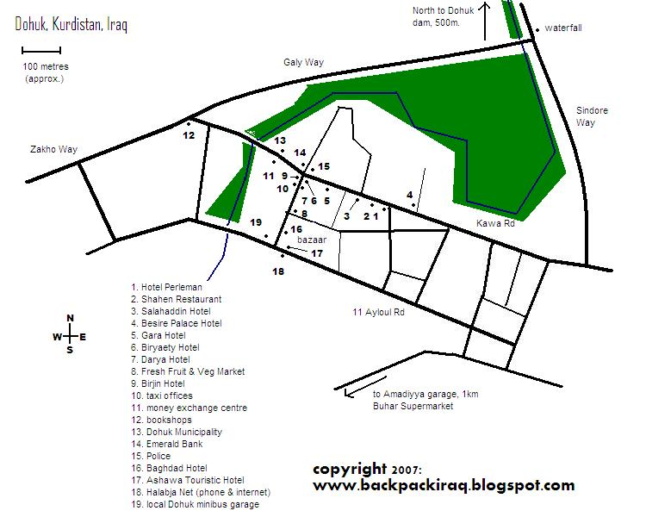
What to see

Dam
Don’t miss the walk to the dam. It’s 30min walking to the north from the centre. Before getting to the dam, when you are near a kind of water jet shooting from the lake, look at your right and you’ll see a stair climbing the slope of the mountain. Get there since it’s a nice 30 min trip around some waterfalls with some nice views.

Hotels
There are lots of hotels in Dohuk (see map). Most are on the two main roads either side of the bazaar area- Kawa Road and 11 Ayloul Road. I only checked the prices of the hotels on Kawa Rd, but I'm sure this is a good sample.
I was travelling by myself, and most hotels didn't have such a thing as a single room- a room might have 2 or 3 beds, and costs the same regardless of how many people sleep in it. So keep in mind, prices are probably cheaper if you're not alone.
Keep in mind that electricity is in short supply and will probably go off at least a few times each evening. Unless stated otherwise, all toilets are squat toilets and all showers are just over the floor with a drain in the corner. Hot water is precious if you are lucky enough to get it. "$" refers to US dollars, and is an approximate equivalent. And above all, things change.
Hotel Perleman- 20,000 dinar ($16). This was the best value in town, with a relatively low price, but clean. The friendly guys who run this place can help you with directions around town, and probably invite you to sit and have a chat. Room includes small bathroom, KurdSat TV, small fridge, heating/air con. The door is on the side street 10m from the corner (I stayed here).
Darya Hotel - 15,000 dinar ($12). Good value, apparently very clean. Rooms have private bathroom.
[In Dohuk I’m staying in Darya Hotel which is the cleanest I’ve seen here yet and has an attached bathroom, they ask for 25'000 but went down to 15'000 started away when i asked. There contact details are darya_hotel@hotmail.com or 762 1212 or 722 1047. They also speak good english there.]
Hotel Birjin- $30/single, $40/double. Breakfast included. Sometimes spelt 'Bircin', this 2005-built hotel seems to be the upmarket choice in Dohuk. I almost stayed here just for the beautiful Euro-style toilet & bath. Room has TV and minibar.
Besire Palace Hotel - 25,000 dinar ($20) for something that looked only slightly better quality than Perleman. Plus the reception guy told me a cheaper rate originally, then when I came back to check in it had gone up a lot, then I bargained back down to this price which didn't seem worth it. But, at least it's nice and clean.
Ashawa Touristic Hotel - 25,000 dinar ($20). On 11 Ayloul Rd, this place is overpriced considering you can get the same quality for 10,000 dinar less. n the other hand, perhaps you should try bargaining.
Gara Hotel - 15,000 dinar ($12). Shared bathroom. Not a great hotel, just a step above scungy.
Salahaddin Hotel - looks cheap and crummy, in the lobby at least. The power went out as I came in so I didn't see any rooms.
Biryaety Hotel - 20,000 dinar ($16). Worst value of them all in Dohuk. I made the mistake of staying here my first night. The shared toilets are gross (wear boots as the flush splashes the floor), my bedroom was freezing cold, and there was a large hole in the top of the wall which meant I could clearly hear my neighbour snoring loudly. The satellite TV wouldn't turn on again after I turned it off. Do yourself a favour and stay at the Perleman for the same price, but much better quality.
Biryaety- worse than it looks.

Getting around
All taxis to and from the garages etc seemed to cost 3000 and i found it no problem finding people that spoke english almost every where.

Getting there
In Dohuk, the taxi offices are next to the Hotel Birjin
Dohuk- Erbil, see getting there and away in Erbil

Zakho (9km from the turkish border) - Dohuk: shared taxi (4 passangers) 6000 dinar each person; approx 1 hour.

Around Dohuk

Amedi ('Amadiyah) and Sulaf

90 Km northeast of Dohuk; about 1400 m above sealevel ; surrounded by heights, so looking like a fortress. Archaeologically, the town's history goes back to Assyrian Period and in certain point of time it was the metropolis of Bahdinan Principality.
Relics at Amedi Citadel The eastern Gate (Bab Zebar): This gate is located in the eastern side of the City of Amadiya. Its width was 4 meters, built by Imaduddin Al- Zanki. There on the left side of the gate is the phrase: This gate was renovated by Sultan Othman Beg.
The Minaret: The minaret is located in the middle of Amadiya. It is 30 meters high. There is a spiral staircase by which one can ascend the minaret. The Islamic ornamentation (arabesque) is clearly seen on the minaret. It is said that it was built in the time of Sultan Hussein Wali Amadiua is an ancient town.
Sulaf is a mountain village with a waterfall and nice cafes 4 km before Amadiya.

Getting to Amadiya
Local orange and white taxi charged $47 roundtrip for the three hour journey, including a one hour stop at the waterfall. (Erbil car service quoted $65—they don’t want to deviate from their set routes.
Regular shared taxi (maybe every 2h) are very convenient to get there: they leave from the garage in Erbil and take 1.5h and charge 8000 dinar per person (4 passangers to fill the car)
There’r no regular minibus to get there.
Once in the town don’t be surprised if the police will come to take you at the police station for identification.

Monastery in Al Quash
You could visit the monastery in Al Quash (1hour from Duhok).

Lalish Temple
It is situated 14 km off Ain Sifne township, Shekhaan District centre. According to the Yezidi Mythology,Lalish is the most ancient place on the globe ever discovered. However, Lalish appellation means the Divine Highness. The temple contains symbols that date back to ancient eras; over ages it had sustained military campaigns, aiming at destroying it and annihilating the Yezidis. The temple has been renovated and reconstructed with its parts & sections. Under the Regional Government, the Yezidis have been practicing their rituals amidst a brotherly ambience. The Temple attracts Yezidis from all over the world to perform their cults twice a year. A. Wednesday Feast, on the second day of August yearly.
A. Wednesday Feast, on the second day of August yearly.
B. Gathering Feast, on 6-13 October yearly.

Erbil /Arbil /Irbil /Hewler

The Erbil Governorate is situated south of the Kurdistani Homeland, north of Federal Iraq and in the middle of Kurdistan Region. Geographically, the city of Erbil extends over a vast plain, with 1300 ft. above sea level. Erbil is a dividing line between Great Zab and Little Zab. The capital of Kurdistan, Erbil is 350 km off the Federal Iraqi metropolis, Baghdad

What to see
Arbil citadel (“kala”)
It lies in the middle of Erbil city. It has a round shape with its buildings and
dwellings; 30 m high. It dates back to over 6000 years BC. Hundreds of families live on the Citadel; there are 506 houses distributed over three quarters (Sarai Q., Takya Q. & Top khana Q.). They were built in artistic styles of architecture, particularly the houses of (Hashim Dabbagh Agha, Mulla Salim Chalabi, Ahmad Chalabi, Sheikh Jameel Ali Afandi, Haji Rasheed Agha). Additionally, there are the Great Mosque and Citadel Bath built in 1775 AD. The Citadel was famous for having most of the idols and was a centre for heroic deeds by the modern civilization figures; also, it was wellknown as Defeated Holako's Castle. However, normal life is still ongoing in the Citadel. As discovered by archaeologists, the Citadel holds many significant remains of various historical races; 5000 year-old relics can be found within its inside parts, but have not yet been researched fully.
Inside the citadel the textile Museum & antique shops next door (ask for Lolan Mustefa mine of info. on region).

Sheikh Chooli Minaret
The minaret was built under Sultan Mudhaffaruddeen. It dates back to 543-586 AD, to the west of Erbil city. It has octagonal curves rising to 14.5 m. The spiral Minaret full height is 21.5 m. Peculiarly splendid kufi calligraphy can be seen; the names of Muhammed and Mas'oudi Muhammadi the builder of the minaret were inscribed. Nowadays the Minaret lies in a new and green park, a good place a have a rest and to see Kurdish mother spending time with their kids.

Al- Sawwaf Mosque
It is located on the (Thirty meter) Street , next to the Kurdistan Region Bank, Constructed in the year 2003 according to Islamic architecture. It combines between modernism and heritage.

St. Joseph Church
The church is located on Erbi-Ainkawa main road. It is one of the eminent churches in Ainkawa subdistrict. Its total area is 10000 M2 of which the premises take up 950 M2. In 1978, it was built according to the ancient Babylonian design.

Erbil Civilization Museum
The museum is on kirkuk Road between the 30m street and the 60m street , near Sheraton Hotel. It is rich invarious antiquities, statues, remains of Erbil & surrounding areas ancient civilization. It holds a great archaeological library that is of benefit for historians and archaeologists.

The Great Bazaar
Generally, markets are interrelated in the city of Erbil. At the city centre, there is the old Great bazaar, known as (Qaysari) market. It includes many special shops and stores selling fabrics, folkloric manufactures, gold, women requirements; places for tailoring men's clothes and scores of shops exclusively selling breakfast meals, like yogurt, cheese and honey.

Martyr Sami Abdur-Rahman Park
The park is situated on 60-m St, opposite to Kurdistan Parliament Building. It is beautiful, integrated and of tourist peculiarity. It is constructed by the Regional Government as per modern urban styles. It includes a swimming pool, statues, casinos and car parking garage.

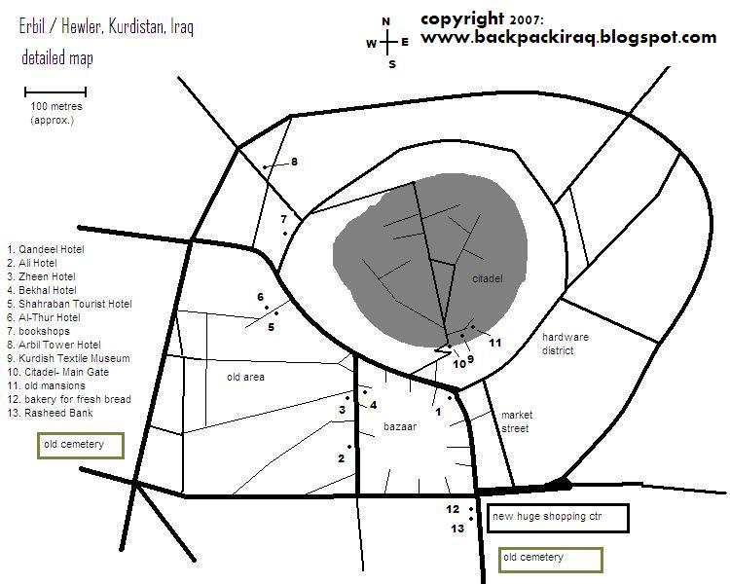

Please note that the building marked as 'new huge shopping ctr' is called the Nishtiman shopping mall (opened February 2007), as it overlooks Nishtiman Square.

Post office
The post office in Erbil is near the citadel and easy to find if you just ask any one for Bareed (post), a post card to Europe cost 1000 and you have to send it in an envolope
[Easy? Oh my God, I spent one afternoon looking for it! I also kept on repeating this magic word, but it didn't help much! The post office is open only till 1 pm. I had to pay 1500 for a postcard to Europe (in an envelope)!]

Hotels:
Erbil has many hotels (see maps), from the horrendous to the luxurious. Some of these places have the potential to set themselves up as a good quality backpacker hostel. Somewhere like the Qandeel or Zheen or Ali Hotels. It'll just take someone with the will and knowledge to make it happen. Even the hellish Al-Thur Hotel could be set up as a good place, it's certainly got plenty of rooms. Every place would be better if only hotels would place a value on cleanliness and high standards. I think it can and will happen, it might just take a 'critical mass' of tourists to get it to that stage.
I was travelling by myself, and most hotels didn't have such a thing as a single room- a room might have 2 or 3 beds, and costs the same regardless of how many people sleep in it. So keep in mind, prices are probably cheaper if you're not alone. Also, try bargaining.
Keep in mind that electricity is in short supply and will probably go off at least a few times each evening. Unless stated otherwise, all toilets are squat toilets and all showers are just over the floor with a drain in the corner. Hot water is precious if you are lucky enough to get it. "$" refers to US dollars, and is an approximate equivalent. And above all, things change.
Qandeel Hotel - 20,000 dinar ($16). In the curved building on the corner facing the main gate of the citadel, Qandeel offers the best value of the cheaper hotels I looked at. Pretty clean, satellite TV and private bathroom (in some rooms). If you ask, they will find someone for you to share a room with for 10,000 dinar. I stayed here.
Ali Hotel - 15,000 dinar ($12). TV in room, bathroom shared. Clean-looking.
Zheen Hotel - 20,000 dinar ($16) per single bed, in a shared room, with toilet. I suspect bargaining may be possible here.
Zagros Hotel - 30,000 dinar ($24). Next to the Ali Hotel, didn't get a chance to look at a room.
Bekhal Hotel - 30,000 dinar ($24). Across the road from Zheen Hotel, this place looked clean from the lobby. Didn't see a room, but probably ok.
Arbil Tower Hotel - 55,000 dinar ($44) / single. A tallish brown building a bit away from the bazaar, this place is an older hotel that was once the best in town. Arbil Tower Hotel (Very central hotel at the base of the citadel and old city. UN staff stay here. It’s seedy and so-so clean but staffare helpful. E-mail: arbil_tower@hotmail.com Tel: 222-6600 & 223-0094.)
Erbil International Hotel - a.k.a. "The Sheraton". This is the swankiest place in the city, and you can see its 10-floor blue glass exterior from the bazaar area. Price- very expensive. Features- restaurant, bar (with Corona or Heineken for 8,500 dinar/ $6.50), travel agent (although tickets are issued elsewhere), and a branch of the Emerald Bank, where you can apparently withdraw money on a Visa Card (NOT MasterCard, to my displeasure). Even though staying here is a pipe dream, its worth a visit if you're craving a good quality toilet, Euro-style.
Shahraban Tourist Hotel - $25. Claimed to be the cheapest place in town. The fact that they lied makes me disinclined to recommend them.
Al-Thur Hotel - 15,000 dinar ($12). (Opposite the Shahraban Tourist Hotel). Though the cheapest place in town, it's for a reason. This place has the aesthetics of a Soviet orphanage, with dark, bleak, asylum-style corridors and bare rooms with the charm of a prison cell. There were cigarette ashes and other dirt on my floor, nothing had been cleaned, and the basin in the odourous bathroom was loose. While the staff were friendly, this is the worst hotel I've ever stayed in in my whole life. Please, don't settle for this hole, like I did on my first night in Erbil. Stay at the Qandeel, Ali or Zheen.
There are numerous other places to stay, mainly around the bazaar area but also a few more pricey ones near the Arbil Tower Hotel. Always check on prices and ask to see your room before you check in.

Erbil International Hotel (“Erbil Sheraton” $200 plus $20 tax for single or $240 plus $24 in taxes for a double including breakfast and Internet. Best hotel in Iraq but cut off from town & people and Fort Knox atmosphere with a “Control Room” where they search you thoroughly before you go through metal detectors at reception and search lights on the roof which pierce the night (and are an easy target). Favored by US military and rich Kurdish expats.

Getting around
All taxis to and from the garages etc seemed to cost 3000 and i found it no problem finding people that spoke english almost every where.

From the airport to the city
Exiting from the airport jump on the brand new bus. You won’t need a ticket since it’ll take you to the first check point (2km) for free. There you’ll have to find a car to get Erbil (10Km), since there are no public means of transport. (taxi: 12.000 dinar)
Getting there and away
In Erbil, get in a local taxi and ask for the "Suly Garage" if you're going to Sulaymaniyah
Details about Erbil Sulaymaiyah transport see Sulaymaiyah getting there and away

Dohuk – Erbil. Taxi, 16,000 dinar ($12) per person. Approx 3 hours. The road goes close to Mosul, but doesn't actually pass through. Apparently the road is controlled by Kurdish forces, but a few soldiers I saw had Iraqi flags on their shoulders...
There are no minibus from Dohuk to Erbil.

Zakho (9km from Turkish border) - Erbil: $90 per car, approx 4 hours.

Erbil- Dyanah, 2.5h, 6000 dinar, frequent minibus (maybe 5 per days)

From Dyanah there’re no regular transport to Aqrah. If you want to try go at the garage in the morning, or

take a private taxi, they asked me 30.000 dinar for the full car if you are alone. If you are 4 people, 40.000 dinar, namely 10.000 each. I recommend this trip since it’s extremely scenery. From Aqrah you can get a to Erbil easily. It’s a good trip (if you are not in hurry) that let you to go from Erbil to Dohuk skipping Mosul and enjoying the gorgeous mountains..

Around Erbil

Khanzad Castle
Khanzad Castle lies on Erbil-Shaqlawa road and is one of the archaeological sites in the city of Erbil. It dates back to Soran Principality period when Princes ruled (Sulaiman Beg and Princess Khanzad) in Soran district whose capital was Rawandooz then.

Gully Ali Beg Resort (Gally Ali Beg)
130 km east off Erbil governorate centre it is one of the attractive and beautiful resorts in Kurdistan Region. Here the road follows a river inside a narrow gorge for 10 km forming a nice landscape dotted with some waterfalls; in addition to the major one, there are several cascades also. The Gully is round 800 m above sea level, with maximum temperature 35 degrees Celsius in summer and 10 degrees below freezing in winter.

Getting to Gully Ali Beg

You can visit it in a daytrip from Erbil, but you need to leave early in the morning. Take a minibus to Diyanah (2.5h, 6000 dinar) and ask to be dropped off at the first waterfall (the big one). Here you can enjoy the café (only from June to September), then walk aside of the road along the gorge following the river upstream. After 1km you will see a bridge, don’t cross it, but take the old road that detaches from the new one 100m before the bridge. The old road is a nice walk, since it’s close to the cars and it’s dug in the rocks. After 1km there’s an old bridge bombed by Iranians in 1988 that you can cross on foot keeping the right hand side. Then the old road joints still the new one and 500m head there’s another group of small waterfalls with a nice and fresh restaurant. From here it’s worthwhile to walk head still 500m, then the gorge opens and there’s no point to go further. The all walk won’t take more then 1.5h.

To come back to Erbil I don’t recommend waiting for the minibus from Dyanah since they will be all full, but the best is to get a lift to Dyanah (7km) and there at the garage jump on the minibus to Erbil.

Personally I did the trip in two days, sleeping in Dyanah at the only hotel of the town (Binazir, double room 15000 dinar). If you do so, go to the police station as soon as you get in the town. Entering the town from Erbil is on the right 200m before the hotel Binazir, exactly in front of the school. From Dyanah you’ll have to take a private taxi to take you to Gully Ali Beg.

Bekhal Resort
140 km away from Erbil governorate centre, east of Gully Ali Beg, 10 km off Rawandooz district. The maximum temperature is 32 degrees Celsius in summer. Resort is accessible via Gally Ali Beg road or Rawandooz district. It has a huge cataract with pure water falling down the mountain. There are
several folk restaurants and other entertaining places. From early spring to late autumn, tourists head for the resort.

Rabban (Monk) Beya Monastery
Located over a valley with the same name, the monastery, an hour climb from the public road, overlooks Shaqlawa subdistrict. This is not like other shrines, being very much organised. It was used to be a refuge for a group of monks. The track leading to it is rough and strenuous; however, it is visited by people round the year. Down the entrance, there are two large engraved rooms, leading up to a wide gate as the front part of the wall has collapsed. Above this wall, there is a small niche a around which a fable revolves - anyone who succeeds in throwing seven small stones, and having them pass through all, they would attain what is desired. It dates back to the fourth century AD.

Sulaymaniyah
The city of Sulaimaniya is 198 km off Kurdistan Regional capital (Erbil) and 385 km from the Federal Iraqi capital (Baghdad).
Sulaymaniyah (see map) is a beautiful city, encircled by mountain ridges. Locals will tell you that it's the most modern city in Iraqi Kurdistan, the place where new fashions and trends are adopted first... that sort of thing. It has a population close to one million, and like every city in the region, growing quickly. Taxis around town are between 2,000 and 5,000 dinar, depending on the distance. There are also minibuses that ply various routes.

What to see
Museums- not sure exactly where these are. There is one general museum I think (closed Fri, Sat, Sun), and a separate torture museum, often called the 'red prison', detailing the horrors of Saddam's regime (ask for 'Amna Saraca'). Walking distance from the bazaar.
Bazaar- very large, in the centre of town, with some US army surplus available.
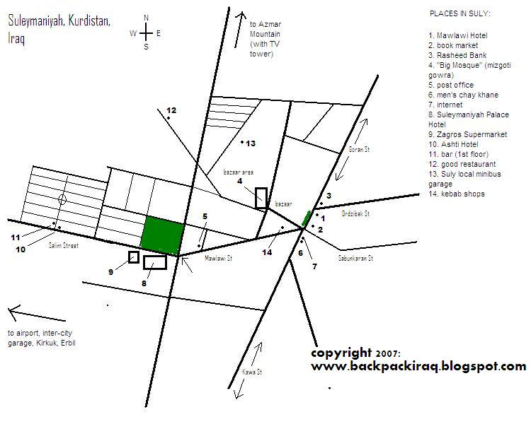

Public Garden
It is situated on ( Salim ) street opposite to ( Sulaimaniya Palace Hotel ) in center of Sulaimaniya city, one of the most gorgeous and expensive gardens that includes several sculptures of Kurdish poets and strugglers, it has an amusement park, resting spots and water fountain.

Azadi Park
An extensive entertainment park constructed by the Regional Government. It includes a variety of trees, playground, swimming pool, statues & artificial lakes. It attracts city residents on many occasions and feasts.

Hotels
Hotels- I don't have much info on Suly's hotels, as I didn't stay in any, but...:
Hiwa Hotel- 15,000 dinar ($12). On Kawa Street. Friendly. Will find a roommate for you, to reduce the price to 13,000 dinar.
Mawlawi Hotel- also on Kawa St, right at the main intersection. I'm told it's quite cheap.
There are quite a few hotels on Kawa Street, near the bazaar.
More expensive hotels are the Sulaymaniyah Palace Hotel (the tallest one on Salim Street) and the Ashti Hotel, also on Salim St.
Eating- Have an awesome Suly-style kebab on Mawlawi Street- it involves bread, kebab, tomato and onion all separate, and you put it together yourself into bite-sized rolls. Delicious! Also eat at a regular workmen's restaurant (ie. #12 on the map), having some quality rice, chicken, soup, fasulye (baked beans) and probably a fun conversation.
drinking- For chay, there is a great men's chay khane (teahouse) at number 6 on the map, where people will be eager to talk about your country's possibilities of investing in Kurdistan and such ambitious topics. There are numerous tea stalls at various intersections on main roads, and it's always worth having one.
I only know of one bar, whose entrance is on the side street to the left of the Ashti Hotel. The bar is on the first floor, and I saw no women inside. Imported Turkish beer and spirits available. Inevitably you'll end up enjoying some local hospitality.
Post office- This is just off Mawlawi Street. It's 1,250 dinar (US$1) for a letter to Australia, so I doubt anywhere else would cost more. Open hours: 8- 13 Saturday- Thursday
Airline offices are on Salim Street, near the Ashti Hotel. Suleymaniyah airport is to the west of the city, not too far away.

Getting around
All taxis to and from the garages etc seemed to cost 3000 and i found it no problem finding people that spoke english almost every where.

Getting there and away
In Sulaymaniyah, "Erbil Garage" if you want to go to Erbil

Erbil – Sulaymaniyah. Taxi: 15,000 dinar ($12) per person. 3-4 hours. The cartel at the 'Suly Garage' in Erbil were shifty guys, constantly changing prices and 'extra charges' for having a large bag. Be firm in your negotiations.
Bus's leave to Suli from Baghdad Garage, they start from 6am and leave every hour and cost 8000 but i dont know until when. It takes about 4 hours
The road between Erbil and Suly passes through the north-eastern suburbs of Kirkuk. I heard that this road is safe, and controlled by Kurdish forces, but the vibes weren't good. Thankfully it only took around 30 minutes to pass through Kirkuk.

Erbil - Sulaymaniyah: avoid Kirkuk town en route by specifying you want to go via Koyia and Dohka. There also minibus passing by here, but definitely it’ll take longer. In Erbil, Arbil Tower staff was quoting $90 roundtrip which is a good price. The roundtrip taxi fare is $50 one way if you go with the long distance taxis

From the garage there’re shared taxi to Baghdad.

Around Sulaymaniyah
Azmar mountain-
If you look up in Suly you'll see the ubiquitous PUK-TV tower on Azmar mountain. You can take a taxi up here, but it's not cheap. Something like 15,000- 20,000 dinar. Great views of the city, and also over the ridges towards more mountains, and Iran to the east.
Nearer but with a great view over the city is the “Goshar” mountain (taxi 10,000- 15,000 dinar)

Darbandikhan Dam
65 km southeast Sulaimaniya, on (Seerwan) River, having a fascinating landscape.
There are a number of tourist cabins, recreational places as well as a folk restaurant. Tourists visit the dam particularly in spring and summer.

Ahmadawa Resort
84 km east of Sulaimaniya, where (Zalm) water spring wells up, flowing in Ahmadawa Valley. At the bottom, it forms several wonderful waterfalls. This resort is covered by ornamental & fruiting tress(walnuts, pomegranates, figs…). It is visited by tourists particularly in spring and summer.

Dokan Lake
Located on Sulaimaniya - Erbil road- (70 km) west of Sulaimaniya. However, the eastern part of the lake contains the Modern Tourist Complex-famous(Ashoor) Hotel. Some years ago, the Regional Government touristically
developed the area through constructing the Contemporary Tourist Village which consists o 60 fully-accommodated tourist cabins.

Sarchnar Resort
5 km off Sulaimaniya city. It is densely surrounded by trees and sweet water springs add fascination to that, attracting tourists, especially in spring and summer. State Tourism Establishment assumed providing all tourist facilities, like resting places, restaurant, club and most famous hotel in the area, in terms of services provided - Sarchnar Hotel.
Halabja
Getting to Halabja is easy for a day. You go out of Hotel Hiwa and go left, take the first right by all the fruit and veg sellers and there is a garage down there on the right. Take the Shahedun bus to the Halapja garage (250) and from there take a bus to Halabja (2500), they leave when full or evey 30 mins it seemed. Make sure you go to Old Halabja (Shaheed Halabja), not the new city (Taza Halabja), its only 80kms and takes about 2 hours.
There is the damaged monument to see there (damaged in protests last year), if you go, go to the visitor's centre next to the monument, the guys in there are surviors of the chemical attack and speak good English and will show you around. You also get a free information book on Halabja, a pin badge and a CD-ROM. Go to the visitors office before you start taking pictures etc as there is a police station opposite who map pick you up. I spent about 40 mins in the police station and in another down the road, they were really nice and no problem but best avoided (they even gave me an armed gaurd for the day to follow me about the city, just a bit OTT!).
The last bus back to Suli leaves about 3.30ish.
(thanks to George a.k.a. scubamonkey69)

Kurdish useful terms

Sorry, I know my transliteration it’s a shame, I hope somebody can do better, but at least is something.

Hello, Good morning= [salam aleikom]
No= [na] or [nahir]

Yes= [bale]
Goodbye= [huàfis]
Thank you= [spas]

Money= [para]
Expensive= [grana]

Key= [klil]
Bus station / garage for taxi= [karaj]

I like Kurdistan= [azmar la Kurdistan]
Kurdistan is beautifull= [Kurdistan juana]

Cities:
Mosul= [Mussel]
Kirkuk= [Karkuk]

